Motivation for Marie Curie and Radiation Unit

Dear Educators,

I am an eighth-grade teacher at Center Grove Middle School Central. I have developed a multidisciplinary unit about Marie Curie and Radiation. You may adopt parts of this unit or the whole, but I want to emphasize the importance of having students study more than the science of radiation. Marie Curie was a remarkable woman who led a very interesting life. A Polish nationalist, Marie left for Paris in order to study, a right not granted to her in her own war torn, occupied country. Pierre Curie, a wonderful scientist in his own right, was always ready to point out that Marie was the driving force behind their research.
As science teachers, we need to help students to understand that important scientific breakthroughs can come from unlikely candidates. We should attempt to inspire an interest in our students of places beyond their homes, communities and country. We need to reach out and bridge the gaps between science and mathematics, language arts and social studies.

I hope you enjoy teaching this unit,

Elizabeth H. Molnar

Indiana State Standards and Indicators Addressed:

8.1.1 Recognize that and describe how scientific knowledge is subject to modification as new information challenges prevailing theories and as a new theory* leads to looking at old observations in a new way.
8.1.4 Explain why accurate record keeping, openness, and replication are essential for maintaining an investigator’s credibility with other scientists and society.
8.1.8 Explain that humans help shape the future by generating knowledge, developing new technologies, and communicating ideas to others.
8.2.1 Estimate distances and travel times from maps and the actual size of objects from scale drawings.
8.2.4 Use technological devices, such as calculators and computers, to perform calculations.
8.6.2 Understand and describe that the accidental discovery that minerals containing uranium darken photographic film, as light does, led to the discovery of radioactivity.
8.6.3 Understand that and describe how in their laboratory in France, Marie Curie and her husband, Pierre Curie, isolated two new elements that were the source of most of the radioactivity of uranium ore. Note that they named one radium because it gave off powerful invisible rays, and the other polonium in honor of Madame Curie’s country of birth, Poland. Also note that Marie Curie was the first scientist ever to win the Nobel Prize in two different fields, in physics, shared with her husband, and later in chemistry.

National Science Standards

UNDERSTANDINGS ABOUT SCIENTIFIC INQUIRY

- Scientific explanations emphasize evidence, have logically consistent arguments, and use scientific principles, models, and theories. The scientific community accepts and uses such explanations until displaced by better scientific ones. When such displacement occurs, science advances.
- Science advances through legitimate skepticism. Asking questions and querying other scientists' explanations is part of scientific inquiry. Scientists evaluate the explanations proposed by other scientists by examining evidence, comparing evidence, identifying faulty reasoning, pointing out statements that go beyond the evidence, and suggesting alternative explanations for the same observations.
- Scientific investigations sometimes result in new ideas and phenomena for study, generate new methods or procedures for an investigation, or develop new technologies to improve the collection of data. All of these results can lead to new investigations.

UNDERSTANDINGS ABOUT SCIENCE AND TECHNOLOGY
- Many different people in different cultures have made and continue to make contributions to science and technology.
- Perfectly designed solutions do not exist. All technological solutions have trade-offs, such as safety, cost, efficiency, and appearance. Engineers often build in back-up systems to provide safety. Risk is part of living in a highly technological world. Reducing risk often results in new technology.
- Technological solutions have intended benefits and unintended consequences. Some consequences can be predicted, others cannot.
SCIENCE AND TECHNOLOGY IN SOCIETY
- Societal challenges often inspire questions for scientific research, and social priorities often influence research priorities through the availability of funding for research.
SCIENCE AS A HUMAN ENDEAVOR
- Women and men of various social and ethnic backgrounds--and with diverse interests, talents, qualities, and motivations--engage in the activities of science, engineering, and related fields such as the health professions. Some scientists work in teams, and some work alone, but all communicate extensively with others.
- Science requires different abilities, depending on such factors as the field of study and type of inquiry. Science is very much a human endeavor, and the work of science relies on basic human qualities, such as reasoning, insight, energy, skill, and creativity--as well as on scientific habits of mind, such as intellectual honesty, tolerance of ambiguity, skepticism, and openness to new ideas.
HISTORY OF SCIENCE
- Many individuals have contributed to the traditions of science. Studying some of these individuals provides further understanding of scientific inquiry, science as a human endeavor, the nature of science, and the relationships between science and society.
- In historical perspective, science has been practiced by different individuals in different cultures. In looking at the history of many peoples, one finds that scientists and engineers of high achievement are considered to be among the most valued contributors to their culture.

Marie Curie and Radiation Unit

DAY 1
Introduction to Marie Curie

Pre-requisite knowledge – periodic table with emphasis on counting protons and neutrons in atoms and an understanding that an element is determined by the number of protons it contains. Also an understanding of isotopes is required.

Mind Capture (Bell work): On the board write – “In your science journals, please write the names of as many famous scientists as you can recall.” With student or teacher at the board to write responses, ask students to share one or two of their entries, calling on as many raised hands as you can in a five minute period of time. Students will undoubtedly name many male scientists with few to no female scientists. Ask students to consider what these scientists have in common. (Perhaps they’re all the same race, perhaps students envision all successful scientists as being old… Of course, gender is the point of the mind capture.)

Alternative Mind Capture (Bell work): On an overhead projector or with a computer projector, place a picture of Marie Curie in her laboratory. Challenge students to make as many observations of and inferences about the woman in the picture as possible in their science journals. If your students are young, you might ask leading questions referring to her occupation, personality, etc. Once students have shared their observations, pass out the following short biography of Marie Curie. You can also have students check off incorrect assumptions as they read the biographies and perhaps add more information as a method of note-taking.

You may want to have a list of famous female scientists, such as Rosalind Franklin and Jane Goodall, and their contributions handy.

Activites:

Have students read a short biography of Marie Curie. A quick google search yields many of these such as the Nobel Prize biography page from

http://nobelprize.org/nobel_prizes/physics/laureates/1903/marie-curie-bio.html

see Appendix E

Tell students that they’ll be learning more about Marie and Pierre Curie in the coming weeks. This is a good time to introduce the Marie Curie project. (see Appendix A-D) Either assign partners or allow students to choose their partners.

I will show two films as background for the projects. During the films students will take notes on their project sheets, attempting to fill in information about their required topics. Students may only watch one of the films depending on which project they choose while working with their partners during the showing of the other film. All students will watch the Marie Curie Walking Tour of Paris, France and fill out the corresponding student worksheet. See appendix N

Those preferring to do the children’s book will probably also want to watch the Children’s Animated Classics Marie Curie movie. Those preferring to do the museum project will find the Marie Curie walking tour I filmed in Paris, France and put together using Microsoft’s Movie Maker, particularly useful.

Because the museum project is more ambitious, you may want to offer an incentive for doing the project, such as extra credit. In our school we give AAAs (Academic Attitude Achievement Awards) which are certificates used in school-wide drawings for goodies from our Parent’s Supporting Students Association every month!

Homework: Read Radioactivity: Historical Figures in order to get an idea of how Marie Curie came to work with radiation in the first place. Be ready to discuss the article tomorrow. See appendix O

Marie Curie and Radiation Unit

DAY 2
Introduction to Alpha and Beta Radiation

Day 2 is a good day to introduce radiation. A very helpful teacher’s page with background information is: http://www.nrc.gov/reading-rm/basic-ref/teachers/unit1.html#activity_1

Mind Capture (Bell work): On the board write – An atom of one element can change to become an atom of another element. This is called transmutation. What would have to happen to an atom in order for it to undergo transmutation?

(Answer: The atom would have to lose or gain one or more protons since it is the number of protons that determines which element an atom is called.)

Explain that when the number of protons and neutrons in the nucleus of an atom are not the same or close together, the nucleus, held together by strong nuclear force, is unstable. As a result, the atom will emit particles, and while doing so, energy, to bring the number of protons and neutrons closer together. The energy emitted in this process is called radiation. At our school, eighth graders study two types of radiation, alpha radiation and beta radiation.

This is a great time to discuss the benefits and harm of radiation. You may, however, want to address this while discussing Marie Curie.

In alpha radiation, the nucleus ejects two protons and two neutrons. I once had a student ask me how that brought the number of protons and neutrons closer together. I’m not a math person, so I had a momentary pang of panic. It is a wonderful question, though, and you might like to pose to your students as bell work one day! I explained it this way (hoping to heaven it made sense!):

Pretend you invite 9 people to your house after school; that makes 10 people including you. You want to share a snack with your friends, but you only have 8 cookies. To share evenly, each person only receives 80% of a cookie. Let’s say the next day, you invite 2 fewer people to your house after school; now, there are only 8 of you. Your mom (so unthoughtful!) only bought 6 cookies (2 less than before). Now, each person only receives 75% of a cookie. You have taken away the same number of cookies as people, but the percentage of cookie per person changed!

With this explained, you will want to demonstrate the effect of alpha radiation on an atom with the following series of questions:

If Carbon-14 undergoes alpha radiation:

Carbon-14 has:
How many protons? 6
How many neutrons? 14 – 6 = 8
If Carbon-14 loses 2 protons and 2 neutrons through alpha radiation, it has:
How many protons? 4
How many neutrons? 6
If an atom has 4 protons, what element is it? Beryllium
So, after transmutation as a result of alpha radiation, an atom of Carbon-14 becomes Beryllium-10!!!!!!!

In Beta Radiation, a neutron in the nucleus of an atom splits, creating a proton and an electron. The proton remains in the nucleus (where protons belong) while the negative electron is emitted from the nucleus as a beta particle (with energy of course – Radiation). The result is an atom with one more proton than it had before, which causes transmutation, and one fewer neutron.

If Potassium-40 undergoes beta radiation:

Potassium-40 has:
How many protons? 19
How man neutrons? 40 – 19 = 21
If Carbon-14 gains 1 electron through beta radiation, it has:
How many protons? 20
How many neutrons? 20
If an atom has 20 protons, what element is it? Calcium
So, after transmutation as a result of beta radiation, an atom of Potassium-40 becomes Calcium-40!!!!!!!

Note: In my class, we do not address electrons yet. Students will have been told that changing the number of electrons and neutrons in an atom does not affect the name of the atom, but I save talking about electrons until the next unit, chemical bonding.

End class by giving students practice problems or you can call on students to pick elements from the periodic table to undergo alpha and beta radiation. Students love having choices and of course they’ll get a kick out of picking elements with really large numbers and strange sounding names. Kids are so easy to please sometimes! I would start with having students do both types of radiation with each atom and then picking an atom to undergo beta radiation only as the y grow more comfortable. This allows students to really distinguish between the two types of radiation rather than seeing the two different forms of radiation as one long problem.

Marie Curie and Radiation Unit

DAY 3
Introduction to half-life (Half-life Lab)

Day three is a good day to introduce the half-life of a radioactive substance. Because it seems less intimidating to students, I used to introduce half-lives before alpha and beta radiation, but it doesn’t make sense for students to work on a half-life lab when they don’t really even understand what radiation is.

Suggested Bell Work: Choose from a or b or both:
a. Review alpha and beta radiation with some problems on the board for students to answer in their science notebooks
b. Pose the following question to be answered in students’ science notebooks – If I have a 500 g sample of radium-226 atoms and half of the radium atoms in the sample decay (turn into different atoms) every 1,620 years, how much radium will you have left in 6,480 years?

Review the bell work with students. At the middle school level, many students will struggle. Sometimes it is helpful to provide a table for students to fill in.....

Day 0 | Year 1,620 | Year 3,240
500 grams | 250 grams

The answers is: After 4 half-lives, or 6,480 years, there should be 31.25 grams of radium left (undecayed atoms).

Explain that even though we cannot predict when an individual atom of a radioactive substance will decay, we can predict when half of a sample of a radioactive substance will decay pretty well.

There are many version of the half/life penny lab out there that demonstrates allows students to discover this phenomena. I have attached my own version. See appendix F

Modification for advanced students: Go about a more inquiry approach – tell students to model half-life and create data tables giving them only a cup and 50 pennies or Marie coins.

Marie Curie and Radiation Unit

DAY 4 & 5
Pre-assessment and Independent Study (Learning Stations)

Suggested Bell Work: Have students study for a pre-test over Marie Curie, alpha and beta radiation, half-lives and transmutation. Explain that this short pre-test will help students determine how they can best use their time in today’s class.

Note: Students may grade their own pre-tests in a second color, but they should be able to produce it for you to look at if you think that they are not using their time in class to their full advantages. Also, I don’t require my students to memorize any part of the periodic table. They memorize much of it from use anyway and can always grab one when they need it. If you are from this school of thought, you will want to provide your students with a periodic table.

Modification for younger students: If you are doing this unit with a younger group, you may want to collect the pretests, grade them and assign students to specific stations. Eighth grade students are surprisingly well equipped to take control of their own learning.

For pretest, please see Appendix K

Modification for language special ed. students: I have highlighted some important figures and vocabulary in the pre-test to assist students who have tracking problems.

When the pretest is over and graded, students will pick which and how many of the following stations they would like to/should visit, and how much time they’ll spend there.

Possible stations:

Alpha radiation practice with maniupulatives and station leader. Appendix H
Beta radiation practice with manipulatives and station leader. Appendix I
Half-life practice with station leader on board or paper easel. Appendix J
Laptop Station: Bio cubes of Marie Curie
Site: http://readwritethink.org/materials/bio_cube/
Laptop Station: Independent Study of Radium Spa in Montana.
Site: http://www.radonmine.com/
Laptop or book station: Benefits and Adverse effects of radiation
Laptop or book station: French culture during the late 19th century
Note: Students should not just surf this subject. Pre-assign websites!!! The following website is really cool. http://gallery.sjsu.edu/paris/

Station leaders should be students how have mastered the concepts, are leaders and patient teachers. You may want to reward the station leaders for their participation. (Last year I did something like this called playing school. My team had the special education students. I had a few who were mathematical thinkers and LOVED playing the part of teacher!!!!)

Also, for manipulatives. I use transparent colored circles on overhead projectors. One color represents protons and a contrasting color represents neutrons. Students practice making nuclei and then model alpha or beta radiation by taking away or adding protons and neutrons as necessary. This method of using manipulatives makes studying radiation more concrete for visual learners.

While students are at each station, they should be taking notes that you will collect and pass back the next day. For reflective note sheet, please see Appendix G The notes sheet allows students to later review the topics they studied this day and holds students accountable for learning in this loosely structured classroom environment. Also, students will share a reflection over the lesson for you. Hopefully, you will receive honest accounts from your students allowing you to determine whether this classroom management approach works for your pupils.

Homework for days 4 and 5

Lord Kelvin and Marie Curie: Is Radium an Element?

Students will read newspaper articles from 1906 concerning the controversy Lord Kelvin caused by asserting his notion that Radium was probably a compound rather than an element. Marie Curie had not yet been able to completely isolate radium and this question required her to purify radium. This lesson provides a wonderful opportunity to introduce students to the importance of primary sources in historical research. It also offers an opportunity to (to quote Indiana State Standard and Indicator 8.1.4 for science): Explain why accurate record keeping, openness, and replication are essential for maintaining an investigator’s credibility with other scientists and society.

For articles see Appendix L

For questions to accompany articles see Appendix M

Here is an explanation for the controversy:

Radium
Isotopes of radium decay to form radioactive isotopes of radon gas.
It is an element in the decay series of Uranium, each stage is its own element with a different atomic number, I dont think however that Halon is one of them.
Radioactive decay occurs when an unstable (radioactive) isotope transforms to a more stable isotope, generally by emitting a subatomic particle such as an alpha or beta particle.
it goes something like this Uranium238 to thorium234 to protactinium234 to Uranium234 to thorium 230 to radium226 to radon222 to polonium218 to lead214 to bismuth214 to polonium214 to lead210 to bismuth210 to polonium210 to lead206 which is its final stable form.
Both Uranium 235 and thorium 232 have similar decay series with Radon.
- The above answer is a little too complicated. Radium is not considered a chemical compound of Helium and Radon because the reaction that splits Radium into Helium and Radon is radioactive decay (the nucleus of the Radium atom splits into two chunks, one with 2 protons (the Helium) & one with 86 protons (the Radon). Also, Radon & Helium are both inert gases & cannot form chemical compounds, except rarely with Fluorine. What you were asking is like asking why 88 is 88 & not a compound of 86 & 2.

Answer (Why not one more?)
Because in radium (²²⁶Ra) where everything starts, all the protons and neutrons are bound into one nucleus - the ²²⁶Ra nucleus. There are no distinct identities - just the one nucleus. It is an unstable nucleus, but everything is stuck together (with binding energy or nuclear glue) until the instability "wins" and the nucleus decays. It is at that time that those two individual identities appear. The alpha particle, which is 4He with its two protons and two neutrons, breaks out of the nucleus and leaves ²²²Rn behind. Alpha decay of ²²⁶Ra has occurred.

DAYS 6-8
Films and Work Days on Marie Curie Project

Suggested Bell Work: Have students pick up a copy of the Marie Curie Walking Tour video viewing sheet. Challenge students to look over the sheet and fill in any blanks they can before the video begins. For video viewing sheet, see Appendix N

Begin class with the Marie Curie Walking tour video. This video provides students an opportunity, not only to see the places where Marie lived and worked, but to learn a little about the city of Paris itself.

Homework: Many people believed that radium had the power to heal many ailments because it was useful in treating cancer. As a result, the radium became exploited. Cosmetics, fishing line, and many other products were advertised as being infused with radium and sold with huge price tags! Write a letter from Marie to her sister, Bronya, or her husband, Pierre, in response to a question about Marie’s feelings concerning the exploitation of Radium.

Appendix A

Marie and Pierre Curie Project Sheet
Children’s Book

You have chosen to make a biography about Marie Curie in the form of a children’s book. The book must be written at a level a fourth-grade student can understand. I expect the following:

A title page, table of contents page and a page about the author.

The book must be at least 20 pages long and include the following aspects of Marie’s life in chronological order:

Marie’s childhood in Poland
b. Raising money to go to Paris
c. Studying in Paris. An emphasis on her poverty would be great.
d. Marie’s marriage to Pierre
e. Marie’s discoveries and Nobel prizes
f. The importance and misuse of radium
g. Pierre’s tragic death
h. Life after Pierre, including taking x-rays during the war

3. The script should be typed and at least 15 pages of the book need to be illustrated by hand or computer graphics for a perfect grade.

4. The book must have at least seven textured pages (foldables, pop-ups, pullies, raised pictures…)

5. Neatness, grammar, spelling and creativity are important!

Appendix B

Grading Rubric for the Marie Curie Children’s Book

The book has a title page, table of contents and a page about the author. | 3
The book contains at least 20 pages demonstrating an accurate understanding of Marie’s life (on the required topics) in chronological order. | 20
The book is typed. At least 15 pages have hand drawn illustrations or pictures printed off of a computer. | 15
The book has at least 7 textured pages (i.e. foldables, pop-ups, pullies or raised pictures). | 7
The book is neat and creative. Good grammar and spelling are used in the creation of this book. | 5

Appendix C

Marie and Pierre Curie Project Sheet
Museum Exhibit Project

You have chosen to make a museum exhibit about Marie Curie. The exhibit must convey information about Marie Curie in a sophisticated manner. I expect the following:

1. The exhibit must display at least eight different objects representing different periods of Marie’s life.

2. The following categories relating to Marie’s life must be addressed (at least):

a. Marie’s childhood in Poland
b. Raising money to go to Paris
c. Studying in Paris. An emphasis on her poverty would be great.
d. Marie’s marriage to Pierre
e. Marie’s discoveries and Nobel prizes
f. The importance and misuse of radium
g. Pierre’s tragic death
h. Life after Pierre, including taking x-rays during the war

3. The exhibit objects may be made of any artistic medium you like, however, some substances are not allowed in the classroom (such as spray paint or insulation foam). You must you at least three different artistic mediums (such as paintings, hand drawn illustrations, photos, models, historical objects, film or computer animation, hands-on manipulatives etc.) in your exhibit.

4. Each object must have a typed placard describing the significance of the object in Marie’s life.

5. Neatness, grammar, spelling and creativity are important!

Appendix D

Grading Rubric for the Marie Curie Children’s Book

The exhibit has at least 8 different objects representing different (required) periods of Marie Curie’s life.
The objects of the exhibit display at least three different artistic mediums.
Each object has a placard explaining the significance of the object in the overall exhibit.
The exhibit is neat, creative and accurate. Correct spelling and grammar are used on the typed placards.

Appendix E

Biography
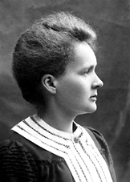Marie Curie, née Maria Sklodowska, was born in Warsaw on November 7, 1867, the daughter of a secondary-school teacher. She received a general education in local schools and some scientific training from her father. She became involved in a students' revolutionary organization and found it prudent to leave Warsaw, then in the part of Poland dominated by Russia, for Cracow, which at that time was under Austrian rule. In 1891, she went to Paris to continue her studies at the Sorbonne where she obtained Licenciateships in Physics and the Mathematical Sciences. She met Pierre Curie, Professor in the School of Physics in 1894 and in the following year they were married. She succeeded her husband as Head of the Physics Laboratory at the Sorbonne, gained her Doctor of Science degree in 1903, and following the tragic death of Pierre Curie in 1906, she took his place as Professor of General Physics in the Faculty of Sciences, the first time a woman had held this position. She was also appointed Director of the Curie Laboratory in the Radium Institute of the University of Paris, founded in 1914.
Her early researches, together with her husband, were often performed under difficult conditions, laboratory arrangements were poor and both had to undertake much teaching to earn a livelihood. The discovery of radioactivity by Henri Becquerel in 1896 inspired the Curies in their brilliant researches and analyses which led to the isolation of polonium, named after the country of Marie's birth, and radium. Mme. Curie developed methods for the separation of radium from radioactive residues in sufficient quantities to allow for its characterization and the careful study of its properties, therapeutic properties in particular.
Mme. Curie throughout her life actively promoted the use of radium to alleviate suffering and during World War I, assisted by her daughter, Irene, she personally devoted herself to this remedial work. She retained her enthusiasm for science throughout her life and did much to establish a radioactivity laboratory in her native city - in 1929 President Hoover of the United States presented her with a gift of $ 50,000, donated by American friends of science, to purchase radium for use in the laboratory in Warsaw.
Mme. Curie, quiet, dignified and unassuming, was held in high esteem and admiration by scientists throughout the world. She was a member of the Conseil du Physique Solvay from 1911 until her death and since 1922 she had been a member of the Committee of Intellectual Co-operation of the League of Nations. Her work is recorded in numerous papers in scientific journals and she is the author of Recherches sur les Substances Radioactives (1904), L'Isotopie et les Éléments Isotopes and the classic Traité' de Radioactivité (1910).
The importance of Mme. Curie's work is reflected in the numerous awards bestowed on her. She received many honorary science, medicine and law degrees and honorary memberships of learned societies throughout the world. Together with her husband, she was awarded half of the Nobel Prize for Physics in 1903, for their study into the spontaneous radiation discovered by Becquerel, who was awarded the other half of the Prize. In 1911 she received a second Nobel Prize, this time in Chemistry, in recognition of her work in radioactivity. She also received, jointly with her husband, the Davy Medal of the Royal Society in 1903 and, in 1921, President Harding of the United States, on behalf of the women of America, presented her with one gram of radium in recognition of her service to science.
For further details, cf. Biography of Pierre Curie. Mme. Curie died in Savoy, France, after a short illness, on July 4, 1934.
From Nobel Lectures, Physics 1901-1921, Elsevier Publishing Company, Amsterdam, 1967
This autobiography/biography was first published in the book series Les Prix Nobel. It was later edited and republished in Nobel Lectures. To cite this document, always state the source as shown above.

Copyright © The Nobel Foundation 1903

Appendix F

Half-Life Lab
Substances with unstable nuclei emit particles and/or energy, known as radiation, in order to become more stable. Although we cannot predict when each individual atom will decay, we can, with a fair amount of accuracy, predict when half of the sample will decay. A radioactive substance has a predictable half-life, a fixed amount of time in which it can be expected that half of the sample will decay.

Materials: 50 pennies or Marie coins, a plastic cup, writing utensil, and lab sheet with data tables

Procedures:
1. You begin with toss 0 and have 50 coins. Record this information in your data table.

2. Put all of your pennies or Marie coins in your group’s plastic cup.

2. With you hand over the opening to avoid loosing coins, shake the cup vigorously.

3. Spill the contents of the cup onto the lab table. This is Toss 1

4. Count how many coins are NOT heads up. These coins represent atoms that have decayed.
In other words, these atoms have become different atoms as a result of radiation.

5. In your data table, record how many atoms have decayed in Toss 1.

6. Do not return decayed atoms to your cup!!!!!!!

7. Put the remaining “alive” or “good” atoms back in the plastic cup.

8. Repeat the shaking and tossing procedure.

9. Again, count, record and remove atoms that have decayed.

10. Place “alive” or “good” atoms back in the cup.

11. Repeat this procedure until all of your atoms have decayed
12. Perform two more trials of this experiment.

13. Find the average # of decayed atoms for every toss and fill in the fourth table. On a separate sheet of graph paper, make a line graph representing the results in your table of averages.
Add to the tables as necessary!

Trial 1 | Trial 2 | Trail 3
  Toss # | # Decayed  Atoms
  0 | 50
  1
  2
  3
  4
  5
  6
  7
  8
  9
  10
  11
  Toss # | # Decayed  Atoms
  0 | 50
  1
  2
  3
  4
  5
  6
  7
  8
  9
  10
  11
  Toss # | # Decayed Atoms
  0 | 50
  1
  2
  3
  4
  5
  6
  7
  8
  9
  10
  11

Average of the 3 Trials

Toss # | Average # Decayed Atoms
0 | 50
1
2
3
4
5
6
7
8
9
10
11

Lab questions:

What do the pennies that are facing “heads up” in this lab represent?

What does each toss of the cup represent?

Why were you instructed to perform this experiment two more times?

In the space below, in complete sentences, write down your observations about the graph you constructed for step 13 of this lab’s procedure.

Define half-live.

How could knowing the half-life of a radioactive substance be useful?

Appendix G
Reflective Notes Sheet

Note to Student: Today and tomorrow you are choosing where you work and how long you stay there based on your needs. This is a privilege and a responsibility. If you enjoy this academic freedom, be sure to write very complete notes at each station. Please take a minute at the end to give me feedback. I would like to know if you found this arrangement enjoyable and useful or not in order to shape future lessons. Thank you for your time!

Name of Station:
Team Leader at Station (if applicable):
Notes from station:

Name of Station:
Team Leader at Station (if applicable):
Notes from station:

Name of Station:
Team Leader at Station (if applicable):
Notes from station:

Name of Station:
Team Leader at Station (if applicable):
Notes from station:

Please use this space for reflection over yesterday’s and today’s class:

Appendix H
Alpha Radiation Practice with Maniupulatives Problems

Note to student instructor: As station leader, it is your responsibility to help people that come to your station as much as you possibly can. You must fight the urge to socialize with your group; you must do your best to keep your group on track. It is important that you help all students, even if you are not friends with them! If you become confused or forget a step, don’t hesitate to ask me for help. That’s my job!!!!! You will use the colored overhead projector circles in order to demonstrate how alpha radiation works.

Choose one color to represent protons.
Choose one color to represent neutrons.
For each problem, ask fellow students to tell you how many protons and neutrons there should be in an atom based on its name and mass number. They may need this practice, so try to avoid just telling them.
Put down enough circles to make a model of the atom’s nucleus.
Ask your group how many protons should be removed during alpha radiation. Remove the 2 protons.
Ask your group how many neutrons should be removed during alpha radiation. Remove the 2 neutrons.
Ask students to look at their periodic tables and tell you what the element that atom has decayed into after transmutation.

Atoms to go through with your group (Note that you are not using examples of radioactive elements but stable elements from the periodic table. I have chosen these in order to keep the nuclei small enough for you to model!):

AN = Atomic Number
AM = Atomic Mass

1. Boron AN-5 AM-11 | 2. Fluorine AN-9 AM-19 | 3. Phosphorus AN-15 AM-31
4. Oxygen AN-8 AM-16 | 5. Aluminium AN-13 AM-27 | 6. Sulphur AN-16 AM-32
7. Beryllium AN-4 AM-9 | 8. Carbon AN-6 AM-12 | 9. Chlorine AN-17 AM-35
10. Neon AN-10 AM-20 | 11. Nitrogen AN-7 AM-14 | 12. Lithium AN-3 AM-7

Appendix I
Beta Radiation Practice with Maniupulatives Problems

Note to student instructor: As station leader, it is your responsibility to help people that come to your station as much as you possibly can. You must fight the urge to socialize with your group; you must do your best to keep your group on track. It is important that you help all students, even if you are not friends with them! If you become confused or forget a step, don’t hesitate to ask me for help. That’s my job!!!!! You will use the colored overhead projector circles in order to demonstrate how beta radiation works.

Choose one color to represent protons.
Choose one color to represent neutrons.
For each problem, ask fellow students to tell you how many protons and neutrons there should be in an atom based on its name and mass number. They may need this practice, so try to avoid just telling them.
Put down enough circles to make a model of the atom’s nucleus.
Ask your group how many neutrons should be removed during beta radiation. Remove 1 neutron.
Ask your group how many protons should be added during beta radiation. Add 1 proton.
Ask students to look at their periodic tables and tell you what the element that atom has decayed into after transmutation.

Atoms to go through with your group (Note that you are not using examples of radioactive elements but stable elements from the periodic table. I have chosen these in order to keep the nuclei small enough for you to model!):

AN = Atomic Number
AM = Atomic Mass

1. Boron AN-5 AM-11 | 2. Fluorine AN-9 AM-19 | 3. Phosphorus AN-15 AM-31
4. Oxygen AN-8 AM-16 | 5. Aluminium AN-13 AM-27 | 6. Sulphur AN-16 AM-32
7. Beryllium AN-4 AM-9 | 8. Carbon AN-6 AM-12 | 9. Chlorine AN-17 AM-35
10. Neon AN-10 AM-20 | 11. Nitrogen AN-7 AM-14 | 12. Lithium AN-3 AM-7

Appendix J
Half-life Practice Problems on Chalkboard or Paper Easel

Note to student instructor: As station leader, it is your responsibility to help people that come to your station as much as you possibly can. You must fight the urge to socialize with your group; you must do your best to keep your group on track. It is important that you help all students, even if you are not friends with them! If you become confused or forget a step, don’t hesitate to ask me for help. That’s my job!!!!! You will lead your classmates through problems on the board. You will demonstrate how to do the first one and then seek your group’s advice on how to do the steps on the following problems.

Be-7 has a half-life of 53 days. If you have a 500 gram sample of Be-7, how many grams do you expect to have at the end of its 3rd half-life?

Answer: 62.5 grams

C-14 has a half-life of 5,730 years. If you have a 350 gram sample of C-14, how many grams do you expect to have at the end of its 2nd half-life?

Answer: 87.5 grams

Pb-211 has a half-life of 36 minutes. How many minutes will have passed after Pb-211 has gone through 5 half-lives?

Answer: 180 minutes or 3 hours

Po-218 has a half-life of 3 minutes. If you have a 6,600 gram sample of Po-218, how many grams would you expect to have left after 9 minutes?

Answer: 825 grams

Rh-106 has a half-life of 30 seconds. If you have a sample of 30 grams, how many grams would you have left at the end of 120 seconds? How many half-lives would the sample have gone through?

Answer: 4 half-lives and 1.875 grams

Zn-69 has a half-life of 57 minutes. If you have a 725 gram sample of Zn-69, how many grams do you expect to have at the end of its 3rd half-life? How many minutes would have passed?

Answer: 90.625 grams and 171 minutes
U-232 has a half-life of 72 years. If you have a 450 gram sample of U-232, how many grams would you expect to have left after 144 years?

Answer: 112.5 grams

Sn-123 has a half-life of 129 days. If you have a sample of 330 grams, how many grams would you have left at the end of 387 days? How many half-lives would the sample have gone through?

Answer: 3 half-lives and 41.25 grams

Appendix K
Marie Curie and Radiation Pre-test

Don’t panic! This is only a pre-test. In order to help yourself, though, you must take this pre-test seriously. Try your best. No one expects perfection. You will grade your own pre-test with a writing utensil that writes in a different color than the writing utensil you use on this test. Find your weaknesses and concentrate on them the next two days in this class. Good luck!

1. Define transmutation:

2. Zn-69 has a half-life of 57 minutes. If you have a 725 gram sample of Zn-69, how many grams do you expect to have at the end of its 3rd half-life? How many minutes would have passed?

3. If Carbon-13 undergoes alpha radiation (This is NOT a multiple choice question!):
a. how many protons will the new atom have?
b. how many neutrons will the new atom have?
c. what is the name of the new atom after the carbon has undergone decay?

4. If Uranium-232 undergoes beta radiation (This is NOT multiple choice!!!!)
a. how many protons will the new atom have?
b. how many neutrons will the new atom have?
c. what is the name of the new atom after the uranium has undergone decay?

5. In complete sentences, please compare and contrast the processes of alpha and beta radiation.

6. In at least one paragraph, please explain why Marie Curie is an important historical, as well as scientific, figure:

Appendix L
Primary Source Articles for Kelvin and Curie Debate over Radium

Special Cable. Copyright, 1908
LONDON. Saturday, Aug. 18 – The Times comments editorially this morning on the radium controversy aroused by what it considers a too facile acceptance by the British Association of the proposition that the evolution of one element into others is an established fact.
The Times objects seriously to Sir Oliver Lodge’s attempt to dispose of Lord Kelvin’s dissent from the proposition, by intimating that Lord Kelvin was not qualified to express an opinion touching upon elemental transmutation, insomuch as he had not read what its advocates had submitted to the British Association.

The Times days that it is ridiculous to suggest that Lord Kelvin would offer in print an opinion that was not fully considered and well grounded. It adds:

“It has become the fashion to accept the transmutation of the elements, and various workers are vying with one another in spinning cobwebs about it, without having bestowed upon the facts anything like the amount of critical industry required to give their novel theories validity.

“The thing corresponds to a certain attitude of mind common among scientific people at the present day. But subjective satisfaction is one thing, and conclusive proof is another. Lord Kelvin does not find the proof. It is pure assumption that he does not know what others think of the evidence, and it is not a very courteous assumption.”

Published: August 18, 1906
Copyright © The New York Times

http://query.nytimes.com/mem/archive-free/pdf?res=9B00E7DB173EE733A2575BC1A96E9C946797D6CF

Published: August 24, 1906
Copyright © The New York Times

http://query.nytimes.com/mem/archive-free/pdf?res=9A03E0D8113AE733A25757C2A96E9C946797D6CF

Published: August 18, 1907
Copyright © The New York Times

http://query.nytimes.com/mem/archive-free/pdf?res=9D00E6DC1F30E233A2575BC1A96E9C946697D6CF

Published: August 10, 1906
Copyright © The New York Times

http://query.nytimes.com/mem/archive-free/pdf?res=9F00EFDF1531E733A25753C1A96E9C946797D6CF

Appendix M
Primary Source Article Questions for Kelvin and Curie Debate over Radium

Attacks Radium School Aug. 10th

- What are Professor Armstrong’s reasons for supporting Lord Kelvin?

- In your own words, explain the point Professor Armstrong is making in the last paragraph of this article.

Madame (Mme.) Curie Thinks Radium Unstable – Aug. 17th

- The evidence Kelvin uses to support his idea that Radium is a compound is that Helium can be separated from it. Try to explain why Radium is considered an individual element despite this fact.

- How many protons and neutrons are in a helium atom? What particle consists of that number of protons and neutrons?

- Does Marie Curie seem offended by Lord Kelvin’s suggestion that radium may not be a pure element? Support your opinion.

Kelvin’s Stand Defended – Aug. 18th

- Please define facile as it is used in the first paragraph of this article.

- Does the first paragraph of this article support Lord Kelvin’s position or Marie Curie’s position? Support your answer.

- The Times is defending Lord Kelvin. In your opinion, was it wrong of Sir Oliver Lodge to make these claims against Lord Kelvin? Support your position in at least three sentences.

Kelvin on Radium’s Origin – Aug. 24th

- What happens when radium undergoes alpha radiation three times. How does your work relate to this article?

Appendix N

Marie Curie Video Quiz

1. Marie Curie was honored as the first woman to do many things. List at least two of these accomplishments from the video presentation.

2. People used radium for many treatments and therapies because it was thought to have many health benefits. What present products or medical advancements are you skeptical about? Why?

3. How did Parisians feel about the Eiffel Tower in the early 20th century (1900s)?

4. What factors led people to finally believe that Marie was, despite her gender, a scientist in her own right?

5. Why did Marie Curie often have apartments on the top floors of buildings?

6. Marie and Pierre could have chosen not to share the secret of isolating radium and used this to their financial advantage. Despite badly needing money for a proper laboratory, they chose to share their information with the scientific community for free. Putting yourself in their shoes, would you have made the same decision. What are the advantages and disadvantages of this choice?

7. Describe Pierre Curie’s death and the possible reasons for his death.

8. Using the scale located at the bottom of this map, how many kilometres is Paris, France (where Marie studies and worked) from Warsaw, Poland (where she grew up)? How many miles is that? How many centimetres is that?

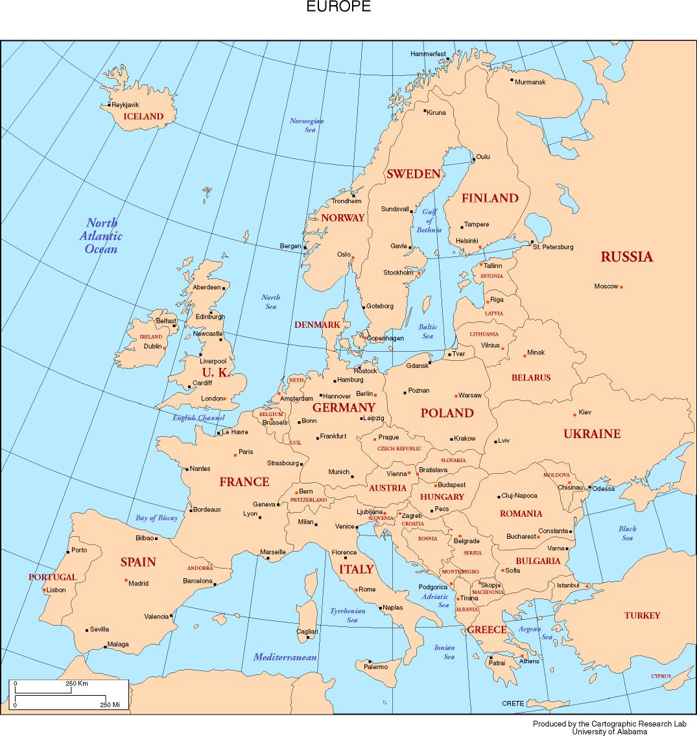

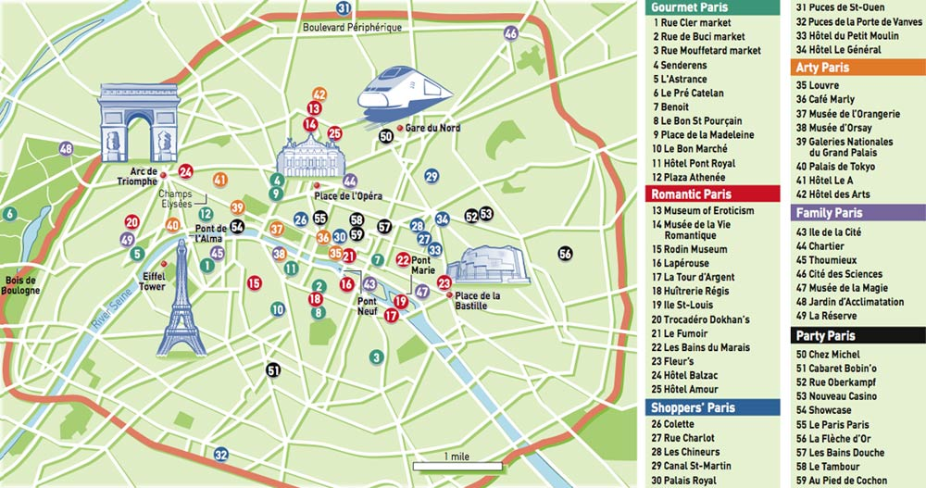

9. Using the map directly above, how many miles is the Rue Cler Market (#1) from the Hotel des Arts (#42)? How many millimetres is that?

10. Using the map directly above, how many kilometres apart are the Musee de la Magie (#47) and the Rue Mouffetard market (#3)? How many hectometres is that?

Appendix O

Radioactivity: Historical Figures

Access Excellence Classic Collection

This article will focus on the efforts of four scientists: Wilhelm Conrad Roentgen, Antoine Henri Becquerel, Marie Sklodowska Curie, and Ernest Rutherford. It emphasizes their contributions to the elucidation of radioactivity and the "key" experiments they performed pertaining to their discoveries. The biographies and photographs are adapted from The Health Physics Society Centennial Calendar by permission of the Health Physics Society.

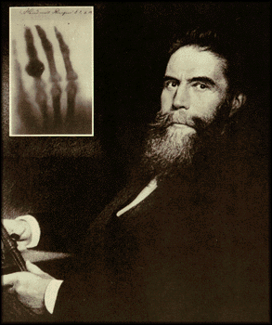
Wilhelm Rontgen ca. 1895. Inset photo: Radiograph of Frau Rontgen's hand.

Wilhelm Conrad Roentgen (1845-1923)
On November 8, 1895, at the University of Wurzburg, Wilhelm Roentgen's attention was drawn to a glowing fluorescent screen on a nearby table. Roentgen immediately determined that the fluorescence was caused by invisible rays originating from the partially evacuated glass Hittorf-Crookes tube he was using to study cathode rays (i.e., electrons). Surprisingly, these mysterious rays penetrated the opaque black paper wrapped around the tube. Roentgen had discovered X rays, a momentous event that instantly revolutionized the field of physics and medicine.
However, prior to his first formal correspondence to the University Physical-Medical Society, Roentgen spent two months thoroughly investigating the properties of X rays. Silvanus Thompson complained that Roentgen left "little for others to do beyond elaborating his work." For his discovery, Roentgen received the first Nobel Prize in physics in 1901. When later asked what his thoughts were at the moment of his discovery, he replied "I didn't think, I investigated. "It was the crowning achievement in a career beset by more than its share of difficulties.
As a student in Holland, Roentgen was expelled from the Utrecht Technical School for a prank committed by another student. Even after receiving a doctorate, his lack of a diploma initially prevented him from obtaining a position at the University of Wurzburg. He even was accused of having stolen the discovery of X rays by those who failed to observe them.
Nevertheless, Roentgen was a brilliant experimentalist who never sought honors or financial profit for his research. He rejected a title (i.e., von Roentgen) that would have provided entry into the German nobility, and donated the money he received from the Nobel Prize to his University. Roentgen did accept the honorary degree of Doctor of Medicine offered to him by the medical faculty of his own University of Wurzburg. However, he refused to take out any patents in order that the world could freely benefit from his work. At the time of his death, Roentgen was nearly bankrupt from the inflation that followed World War I.

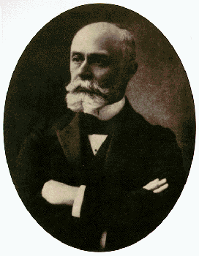
Henri Becquerel
Antoine Henri Becquerel (1852-1908)
Henri Becquerel was born into a family of scientists. His grandfather had made important contributions in the field of electrochemistry while his father had investigated the phenomena of fluorescence and phosphorescence. Becquerel not only inherited their interest in science, he also inherited the minerals and compounds studied by his father. And so, upon learning how Wilhelm Roentgen discovered X rays from the fluorescence they produced, Becquerel had a ready source of fluorescent materials with which to pursue his own investigations of these mysterious rays.
The material Becquerel chose to work with was potassium uranyl sulfate, K₂UO₂(SO₄)₂, which he exposed to sunlight and placed on photographic plates wrapped in black paper. When developed, the plates revealed an image of the uranium crystals. Becquerel concluded "that the phosphorescent substance in question emits radiation which penetrates paper opaque to light." Initially he believed that the sun's energy was being absorbed by the uranium which then emitted X rays.
Further investigation, on the 26th and 27th of February, was delayed because the skies over Paris were overcast and the uranium-covered plates Becquerel intended to expose to the sun were returned to a drawer. On the first of March, he developed the photographic plates expecting only faint images to appear. To his surprise, the images were clear and strong. This meant that the uranium emitted radiation without an external source of energy such as the sun. Becquerel had discovered radioactivity, the spontaneous emission of radiation by a material.
Later, Becquerel demonstrated that the radiation emitted by uranium shared certain characteristics with X rays but, unlike X rays, could be deflected by a magnetic field and therefore must consist of charged particles. For his discovery of radioactivity, Becquerel was awarded the 1903 Nobel Prize for physics.

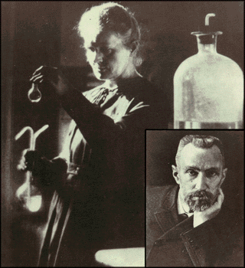
Marie Curie ca. 1920. Inset: Pierre Curie (Marie's favorite picture of her husband).
Pierre Curie (1859-1906)
Marie Curie (1867-1934)
By the time he met Marie Sklodowska, Pierre Curie had already established an impressive reputation. In 1880, he and his brother Jacques had discovered piezoelectricity whereby physical pressure applied to a crystal resulted in the creation of an electric potential. He also had made important investigations into the phenomenon of magnetism including the identification of a temperature, the curie point, above which a material's magnetic properties disappear. However, shortly after his marriage to Marie in 1895, Pierre subjugated his research to her interests.
Together, they began investigating the phenomenon of radioactivity recently discovered in uranium ore. Although the phenomenon was discovered by Henri Becquerel, the term radioactivity was coined by Marie. After chemical extraction of uranium from the ore, Marie noted the residual material to be more "active" than the pure uranium. She concluded that the ore contained, in addition to uranium, new elements that were also radioactive. This led to their discoveries of the elements of polonium and radium, but it took four more years of processing tons of ore under oppressive conditions to isolate enough of each element to determine its chemical properties.
For their work on radioactivity, the Curies were awarded the 1903 Nobel Prize in physics. Tragically, Pierre was killed three years later in an accident while crossing a street in a rainstorm. Pierre's teaching position at the Sorbonne was given to Marie. Never before had a woman taught there in its 650 year history! Her first lecture began with the very sentence her husband had used to finish his last. In his honor, the 1910 Radiology Congress chose the curie as the basic unit of radioactivity: the quantity of radon in equilibrium with one gram of radium (current definition: 1 Ci = 3.7x1010 dps). A year later, Marie was awarded the Nobel Prize in chemistry for her discoveries of radium and polonium, thus becoming the first person to receive two Nobel Prizes. For the remainder of her life she tirelessly investigated and promoted the use if radium as a treatment for cancer. Marie Curie died July 4, 1934, overtaken by pernicious anemia no doubt caused by years of overwork and radiation exposure.

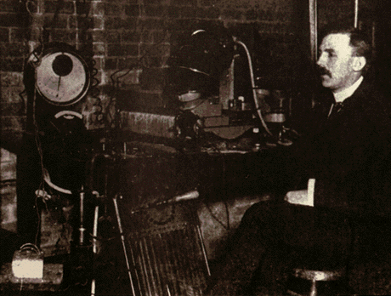
Ernest Rutherford in his Laboratory at McGill University ca. 1903.

Ernest Rutherford (1871-1937)
Ernest Rutherford is considered the father of nuclear physics. Indeed, it could be said that Rutherford invented the very language to describe the theoretical concepts of the atom and the phenomenon of radioactivity. Particles named and characterized by him include the alpha particle, beta particle and proton.
Even the neutron, discovered by James Chadwick, owes its name to Rutherford. The exponential equation used to calculate the decay of radioactive substances was first employed for that purpose by Rutherford and he was the first to elucidate the related concepts of the half-life and decay constant. With Frederick Soddy at McGill University, Rutherford showed that elements such as uranium and thorium became different elements (i.e., transmuted) through the process of radioactive decay. At the time, such an incredible idea was not to be mentioned in polite company: it belonged to the realm of alchemy, not science.
For this work, Rutherford won the 1908 Nobel Prize in chemistry. In 1909, now at the University of Manchester, Rutherford was bombarding a thin gold foil with alpha particles when he noticed that although almost all of them went through the gold, one in eight thousand would "bounce" (i.e., scatter) back. The amazed Rutherford commented that it was "as if you fired a 15-inch naval shell at a piece of tissue paper and the shell came right back and hit you."
From this simple observation, Rutherford concluded that the atom's mass must be concentrated in a small positively-charged nucleus while the electrons inhabit the farthest reaches of the atom. Although this planetary model of the atom has been greatly refined over the years, it remains as valid today as when it was originally formulated by Rutherford. In 1919, Rutherford returned to Cambridge to become director of the Cavendish laboratory where he had previously done his graduate work under J.J. Thomson. It was here that he made his final major achievement, the artificial alteration of nuclear and atomic structure. By bombarding nitrogen with alpha particles, Rutherford demonstrated the production of a different element, oxygen. "Playing with marbles" is what he called; the newspapers reported that Rutherford had "split the atom." After his death in 1937, Rutherford's remains were buried in Westminster Abbey near those of Sir Isaac Newton.

http://www.accessexcellence.org/AE/AEC/CC/historical_background.php

Appendix P
Marie Curie Coins
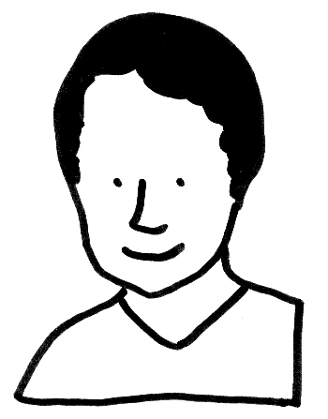
Picture Source:
http://images.google.com/imgres?imgurl=http://www.wink-rightbrain.com/images/1-mariecurie.gif&imgrefurl=http://www.wink-rightbrain.com/faq_example.php&h=447&w=350&sz=17&hl=en&start=25&usg=__5q6qRhv89aN2dAlGhT_iWt6v6nM=&tbnid=xf1EZ5mdzUrUTM:&tbnh=127&tbnw=99&prev=/images%3Fq%3DMarie%2BCurie%2Bhead%26start%3D20%26gbv%3D2%26ndsp%3D20%26hl%3Den%26sa%3DN
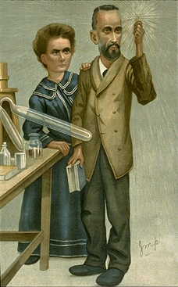
Picture Source:

http://images.google.com/imgres?imgurl=http://home.inreach.com/famdoc/curie.jpg&imgrefurl=http://home.inreach.com/famdoc/artfulscience.html&h=367&w=228&sz=46&hl=en&start=22&um=1&usg=__1jrtxU500q01o7EcTZ4TKR_797Q=&tbnid=Gv8pasYP2m8u9M:&tbnh=122&tbnw=76&prev=/images%3Fq%3DPierre%2BCurie%2Bhead%26start%3D20%26ndsp%3D20%26um%3D1%26hl%3Den%26rlz%3D1T4GGIH_enUS237US237%26sa%3DN

